**Project Name:** QR Code Scanner & Decoder

**Github Link:** https://github.com/projectsforstudents2022/QR_Code_Scanner_Decoder.git

**Why was this project created?**

A Quick Response Code, often known as a QR Code, is a two-dimensional bar code made up of a white background and a grid of tiny black squares. It replaced the more common black bars and white spaces bar codes in popularity thanks to its capacity to contain more data and quick readability. These are readable by specialized software that can draw data from the patterns in the matrix. These codes can accommodate four different types of data, including alphabetic, numeric, binary, and more information than regular barcodes.

**What problem is it solving?**

The project's primary goals will be to identify and, in that order, segment QR codes with arbitrary deformations. Even though they initially appeared to be similar, the objectives have been clearly divided into two since each one has unique strengths and shortcomings. To determine whether they can be used in an industrial setting, it is essential to develop models that can do each of them and evaluate how they operate.

**Entire explanation of project**

* **PROPOSED APPROACH**

A Quick Response Code, often known as a QR Code, is a two-dimensional bar code made up of a white background and a grid of tiny black squares. It replaced the more common black bars and white spaces bar codes in popularity thanks to its capacity to contain more data and quick readability. These are readable by specialized software that can draw data from the patterns in the matrix. These codes can handle four different data types: alphabetic, numeric, binary, and kanji, and can store more data than regular barcodes. An improvement over conventional barcodes, QR codes are utilized in a range of applications, from bitcoin wallet addresses to supply chain management.

The straightforward QR code is utilized in numerous contexts where exchanging information about any object is necessary, including tracking labeled commercial and industrial products, advertising and marketing, the sale of commodities, and identifying business cards, bank accounts, and immigration stamps. The QR code contains the details or information about the object.

* **RESULT**

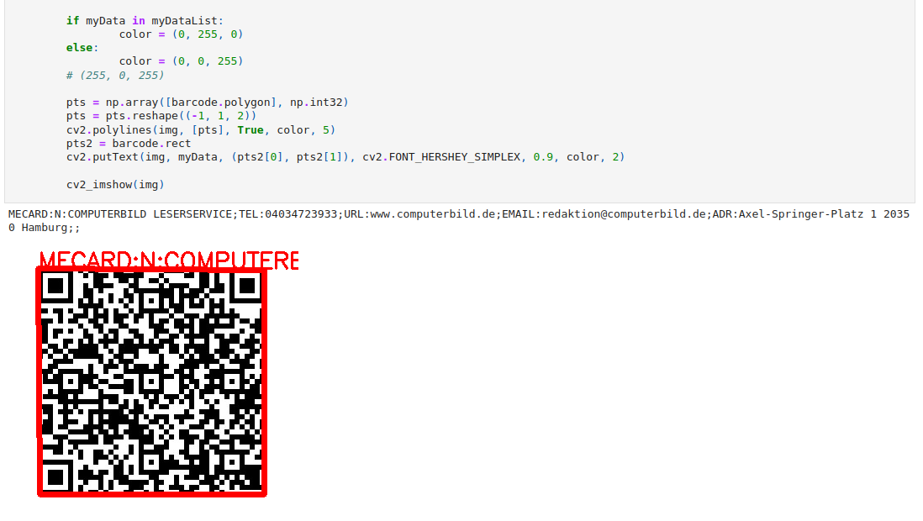

**CONCLUSION**

The QR code is used in many application streams related to marketing, security, lecturers, etc. and is rapidly gaining popularity. As more people become acquainted with it, they begin to employ it appropriately. The acceptance of QR code is quickly reaching significant levels of usage due to the rapid development of smartphone users. Due to the widespread use of QR codes, its security features are grave, including data alterations and data leaks. Text files or a password-protected system may be encoded into a QR Code that can be read by a smartphone. Python, which serves as the primary interface for identifying QR Codes, is used to carry out the operation.